Yi-Chieh Liao

[1]

Implementation of an Stereo Correspondence

*Abstract*—Stereo Correspondence is very important in reconstructing images. In general, with calibrated cameras, the constraints of stereo correspondence are being calculated by setting the *y*-axis of two images to the same. Geometry of two views allows us to constrain where the corresponding pixels for the first image points in the first view must occur in the second view. This paper applies epipolar line to reduce the correspondence problem into 1D search problem along horizontal lines. We will discuss what types of pixels matching algorithms play a better role at finding correspondence. Further, the experiments aim to focus on finding similarity of pixels at correspondence locations and store them in a disparity map (DSI). After that, a dense correspondence map is produced by finding the best points in disparity map.

*Index Terms*—Camera calibration, Stereo image rectification, disparity, Stereo Correspondence, stereo system, Stereo reconstruction, Correspondence problem.

# INTRODUCTION

Stereo correspondence is a fundamental task in computer vision which occurs in various applications such as image reconstruction, image alignment, and image depth estimation. It is one of the important steps for 3D computer vision process in order to reconstruct images. The basic task of stereo correspondence problems is the following: Consider two images that roughly depict the same scene, e.g. two subsequent frames of an image sequence or two images taken by two different cameras, objects in camera’s field of view might be at slightly various locations within the two images caused by the cameras’ different perspectives on the scene. For each pixel in the first image, the stereo correspondence algorithms aim to find its corresponding pixel in the second image [1]. For example, measuring the depth information from a pair of stereo images can be computed by calculating the distance between the location of a specific feature in the first image and its location in the other image. After doing so, we will obtain a disparity map which represents pixels with larger disparities are closer to the camera and smaller disparities are further away from the camera. The dense map can be generated by using the disparity map and we can view the goodness of result by simply comparing the similarity between two images.

The correspondence problem then becomes how to find the closet matching feature region of pixels. Therefore, matching feature pixels between images constitutes a fundamental step in correspondence problem. One of the techniques widely used in matching feature pixels is a square of matching pixels matrix [2]. The matrix is called “window” and the center of the matrix is called “center”. This paper applies the method to generate a correspondence dense map. Figure 1 shows how the comparison works by comparing the window in first image to the corresponding epipolar line in the second image.

The testing images were colorful images so in best case we would have to do three channels comparison. By comparing (RGB) channels respectively to each other. However, for efficiency purpose, we pre-process the color image into grayscale image which only needs to compare one channel and we found the result is extremely close to using three channel comparison.

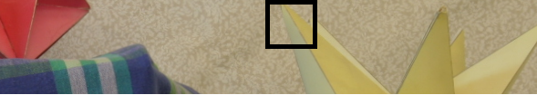

(a)

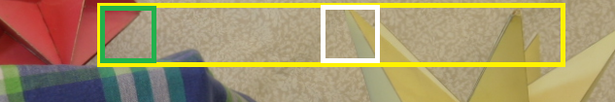

(b)

Figure 1. The black box represents the feature window in first image (a). The yellow rectangle is the range to be compared in the second image (b), each window is being compared in the yellow rectangle by moving center one pixel to the right. The best matching window (white window) will be stored in the disparity map for further use

# window comparison

The technique which conducts the matrix comparison plays a vital rule in finding the best matchup. In this paper, we discuss three kinds of comparison technique to estimate the difference between two windows. Before computing the disparity map, we must convert the two images into grayscale so that we obtain some values (0-255) for each pixel in each window.

Note that we only search horizontally for matching window and not vertically. That is because we assume the images are being rectified. The rectification is to re-project image planes onto a common plane parallel to the line between optical centers [3]. Rectification is essential for ensuring that we only do the window matching horizontally not vertically. In other word, a feature in the same row of the two images.

The first technique is “sum of absolute differences” or “SAD”. SAD is to compute the sum of the absolute differences between each pixel, we subtract each pixel in the window in the first image from the corresponding pixel in the window in the second image. After that, we sum up all of the differences and this shows a value that represents the similarity between the two features. The lower the value means the patches are more similar. This operation will be done every window comparison in each epipolar line. The mathematical formula of SAD is given below:

$$SAD=\sum_{\left(i,j\right)∈R}{\left|f\left(i,j\right)-g\left(i,j\right)\right|}$$

where $f\left(i,j\right)$ denotes to the grayscale of the pixel at *i*-th column and *j*-th row in the first image and $g\left(i,j\right)$ denotes to the grayscale of the pixel at *i*-th column and *j*-th row in the second image.

The second technique is called “Correlation” or “ $C_{fg}$” We take the sum of each pixel grayscale in the first image multiply by the respective pixel in the second image. The mathematical formula of $C_{fg}$ is given below:

$$C_{fg}=\sum_{\left(i,j\right)∈R}{f\left(i,j\right)∙g\left(i,j\right)}$$

The third technique is “Sum of Squared Differences” or “SSD”. SSD is very popular matching technique and it contains the concept of $C_{fg}$ and gives a better performance. he mathematical formula of SSD is given below:

$$SSD=\sum_{\left(i,j\right)∈R}{{\left(f\left(i,j\right)-g\left(i,j\right)\right)}^{2}}$$

$$=\sum_{\left(i,j\right)∈R}{{f(i,j)}^{2}}+\sum_{\left(i,j\right)∈R}{{g(i,j)}^{2} }-2\sum_{\left(i,j\right)∈R}{f(i,j)∙g(i,j)}$$

in which $\sum_{\left(i,j\right)∈R}{f∙g}$ can be viewed as $C_{fg}$.

In order to handle the intensity changes of images, we implement the “intensity normalization”. Intensity changes occur when the camera taking the second image sometimes has slightly different intensity response characteristics from that of the first image. This might cause the issue of illumination in the scene could change. If the scene is imaged by different cameras or sensors, then the output of SSD and $C_{fg}$ matching techniques will become large for windows with the same area in image. As a result, normalizing the pixels in windows before the window comparison is required.

$$\hat{f}(i,j)= \frac{f(i,j)- \overline{f}}{\sqrt{\sum_{\left(i,j\right)∈R}{{\left(f(i,j)-\overline{f}\right)}^{2}}}}$$

$$\hat{g}(i,j)= \frac{g(i.j)- \overline{g}}{\sqrt{\sum_{\left(i,j\right)∈R}{{\left(g(i,j)-\overline{g}\right)}^{2}}}}$$

$$NCC\left(f,g\right)= C_{fg}\left(\hat{f},\hat{g}\right)=\sum_{\left(i,j\right)∈R}{\hat{f}\left(i,j\right)∙\hat{g}\left(i,j\right)}$$

where $\overline{f} is the average of f$ and $\overline{ g} is the average of g$*.*

The performances of these techniques will be discussed in Sec. IV.

# Window size and search range

The window-matching algorithm must know how far distance away from the window center location we want to search. This problem can be viewed as the maximum disparity we expect to find in the images. In fact, we do not need to search the whole row of the image, there exits an upper bound of the disparity of two images.

We set the search range to 100 and 200 which indicated the pixel distance away from the window center.

The window size will affect the output as well, the larger window size indicates the bigger area are being included to concern the similarity between two windows. We found that the bigger window gives us a more complete result, but the accuracy is lower than the small window. Small window has advantages at matching corner features which are usually small. In addition, when it comes to time conserving, small window outperforms big window.

We also found that large window generally appears to generate a less noisy disparity map which means the result image looks smooth and well-fitted. On the other hand, small window tends to have complicated and noisy disparity map but performs well at matching tiny features and more precise overall.

# Results

The testing images used to verify the performance of SAD, $C_{fg} and$ SSD techniques are given in Figure 2 below:

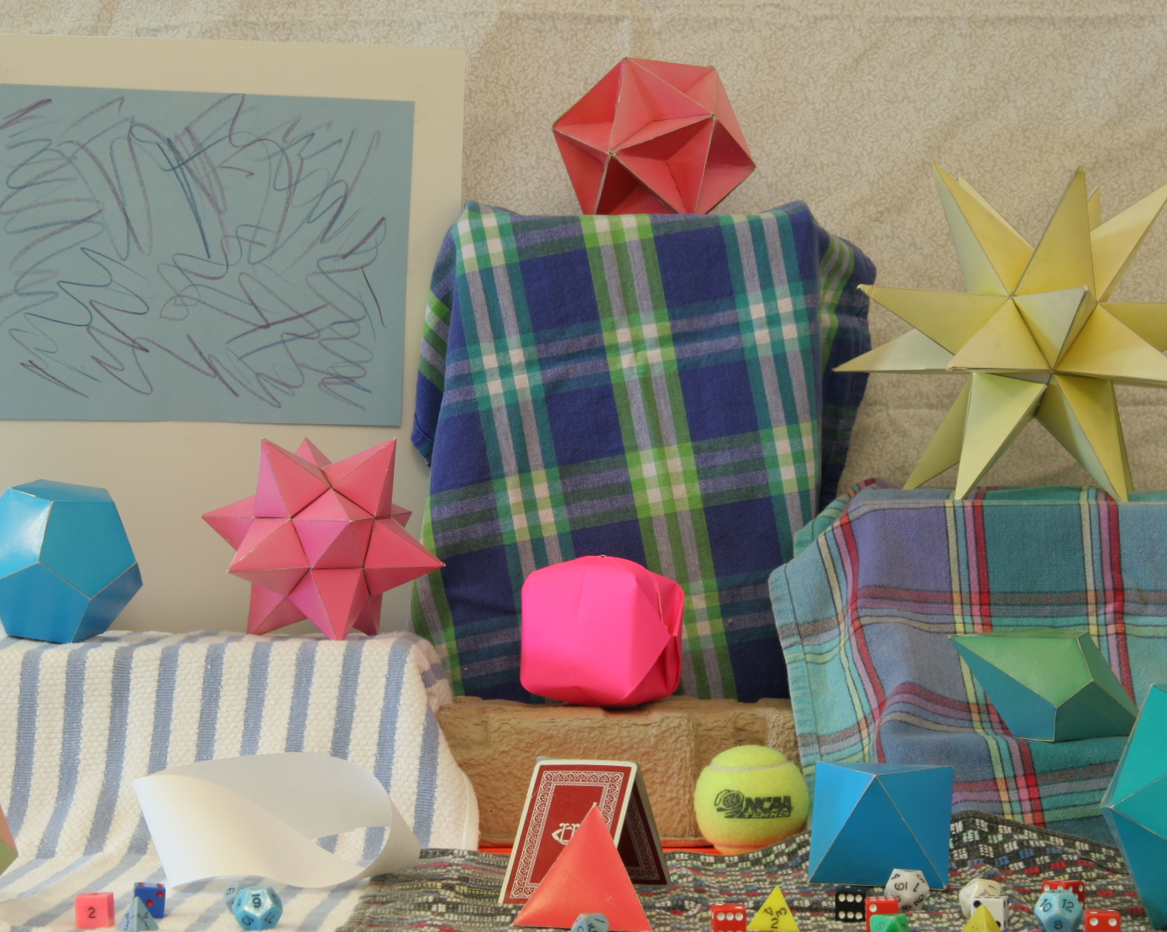 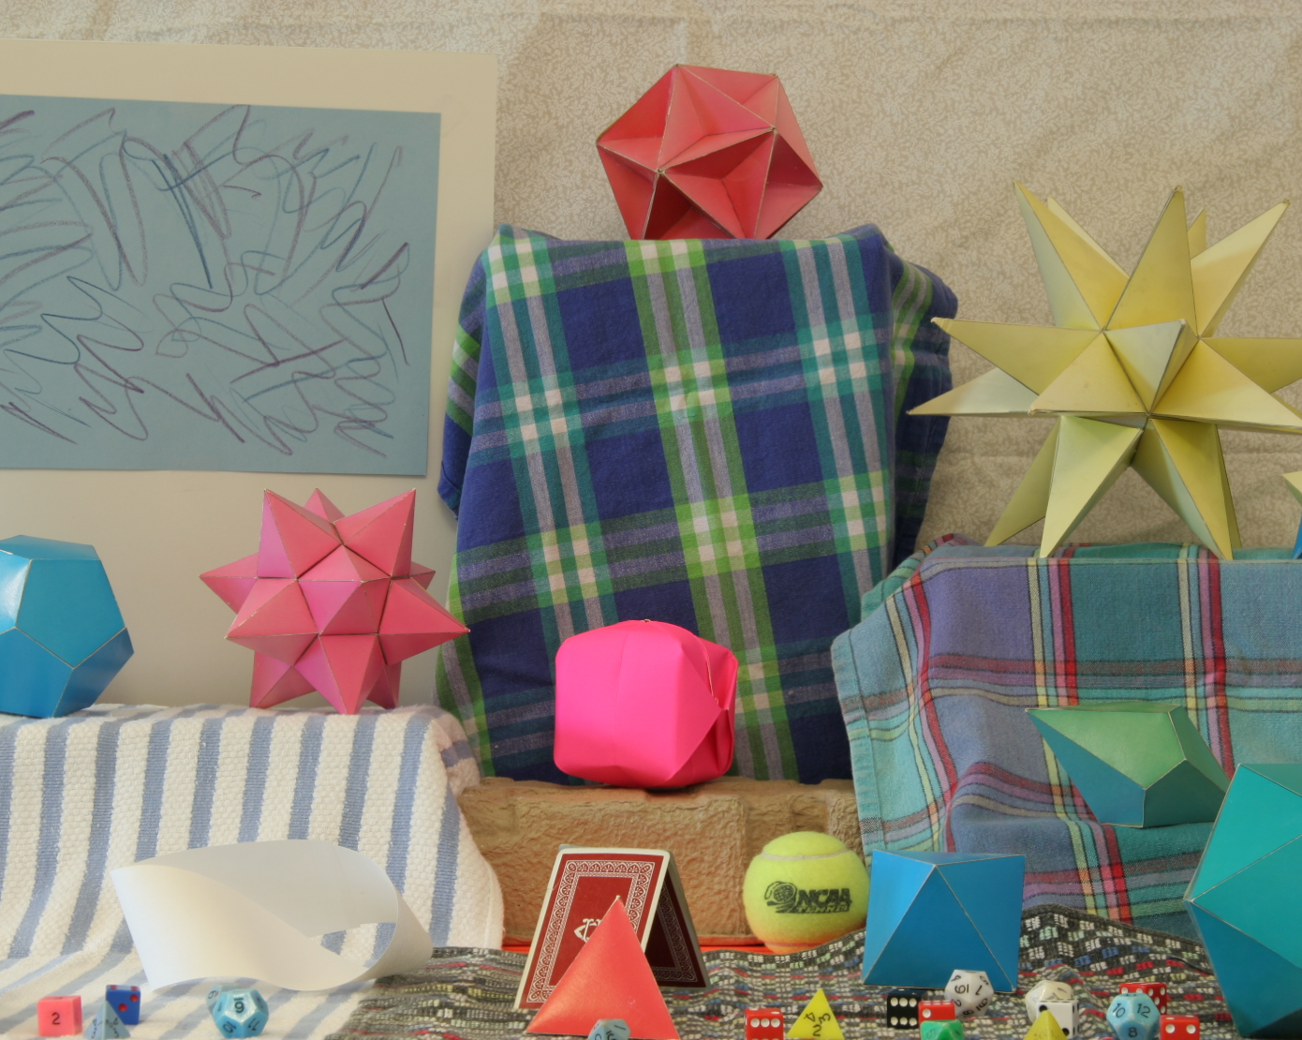

Figure 2. The two images for testing

As we can see, the right image looks very similar to left image but is taken by a camera slightly moves to the right.

We perform these techniques AD, $C_{fg}, and$ SSD to conduct window-matching for the given two images. Figure 3 shows that using SAD is better than all other methods. Moreover, SAD has overall less computation cost than SSD. SAD only takes 3185 seconds while SSD needs 6719 sec to finish. It is obvious that SAD has better performance than others, so in the following section we only discuss using SAD as experiment setup.

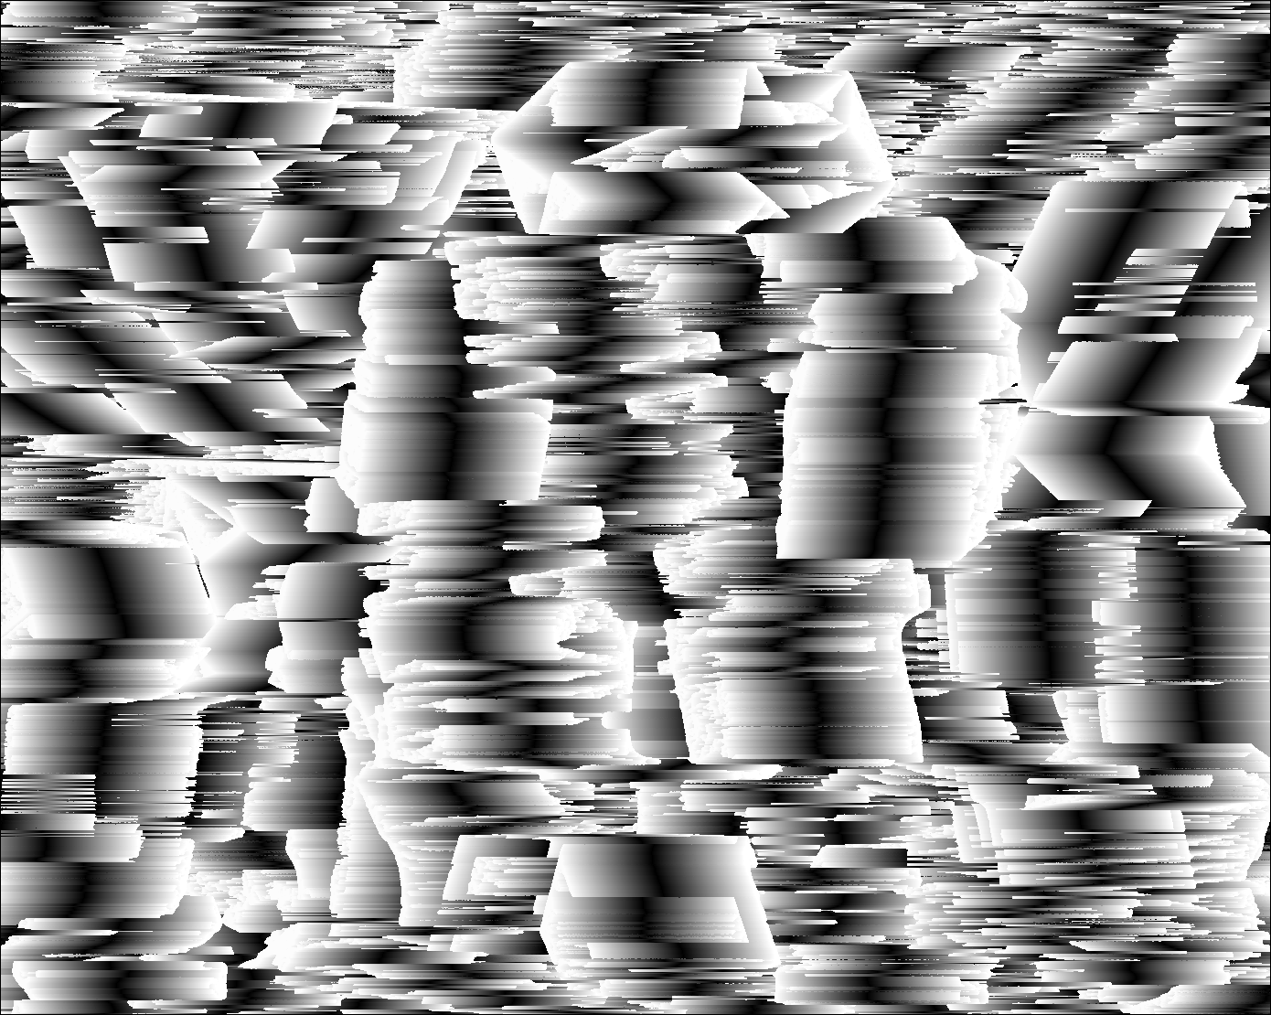 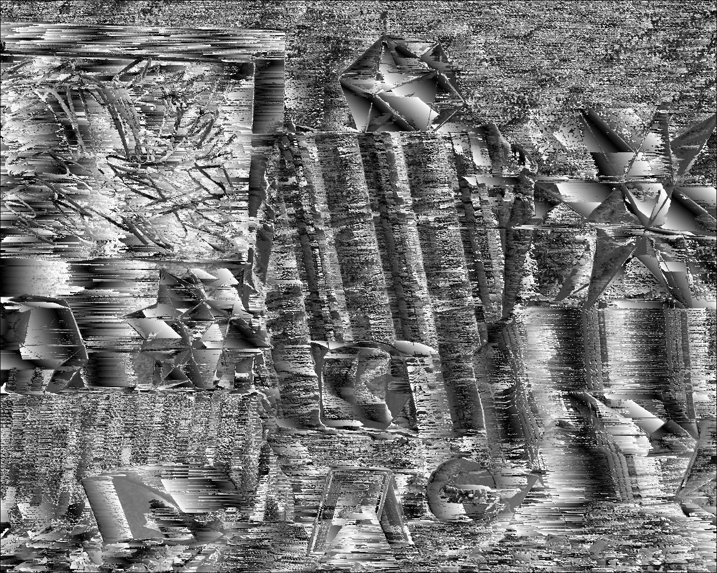

(a) (b)

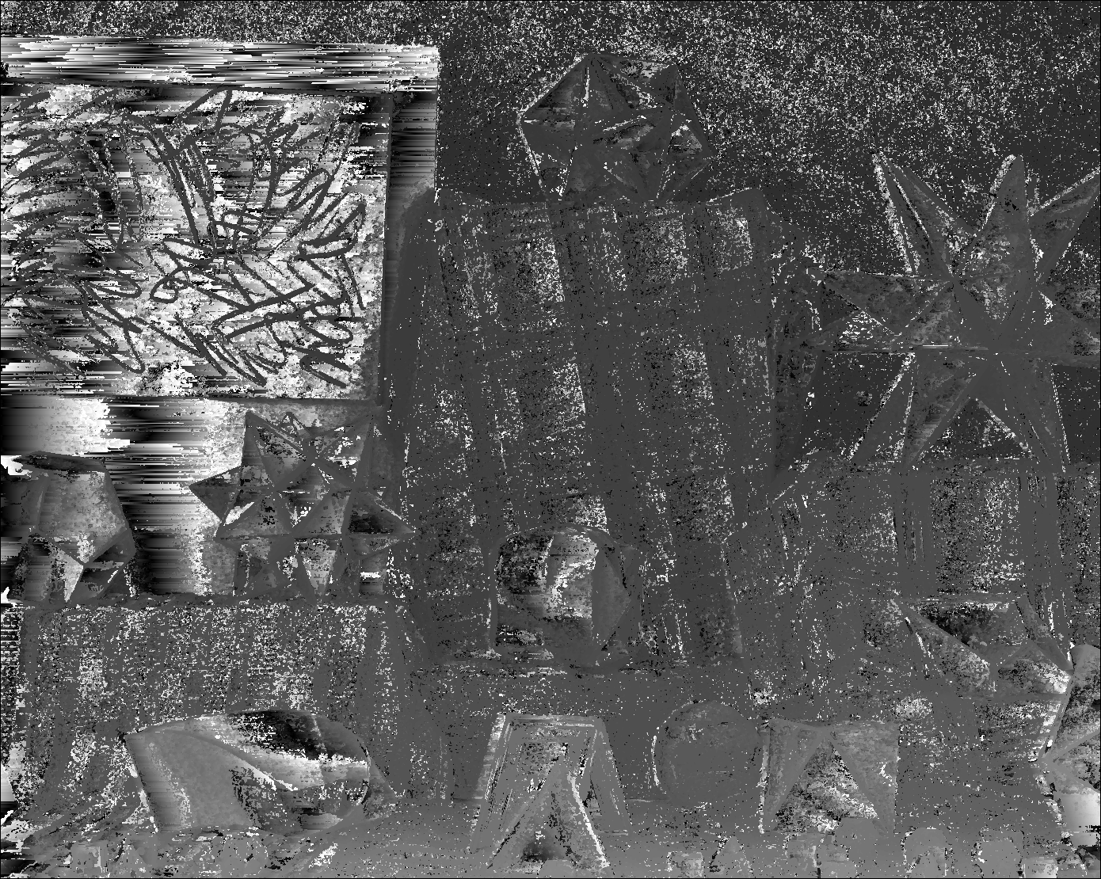

(c)

Figure 3. Results by (a) $C_{fg}$ (b) SSD (c) SAD with window size: 3 and search range: 200

Next, we compare the window size selection by using SAD technique. We run the experiment using window size of 3, 5 and 9, respectively. The experimental results are shown in Figure 4.

 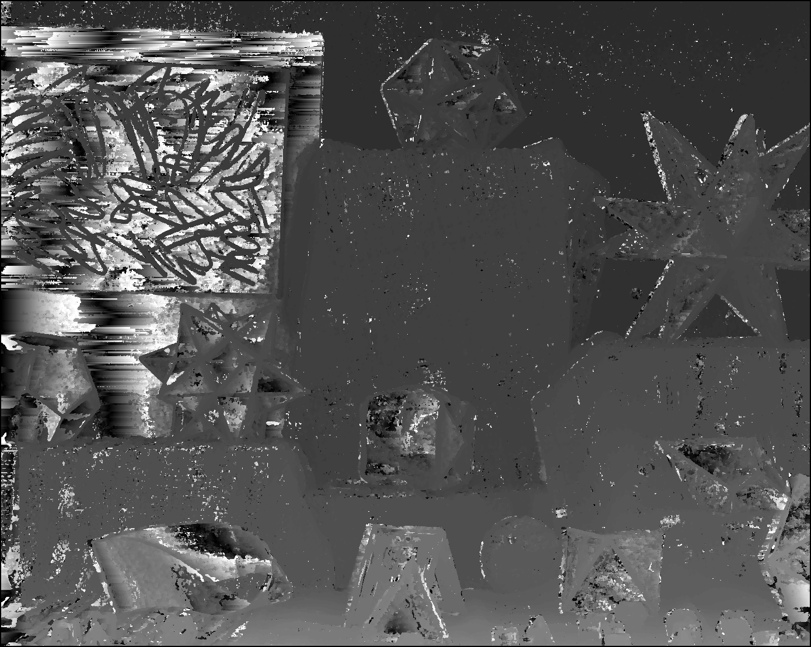

(a) (b)

(a

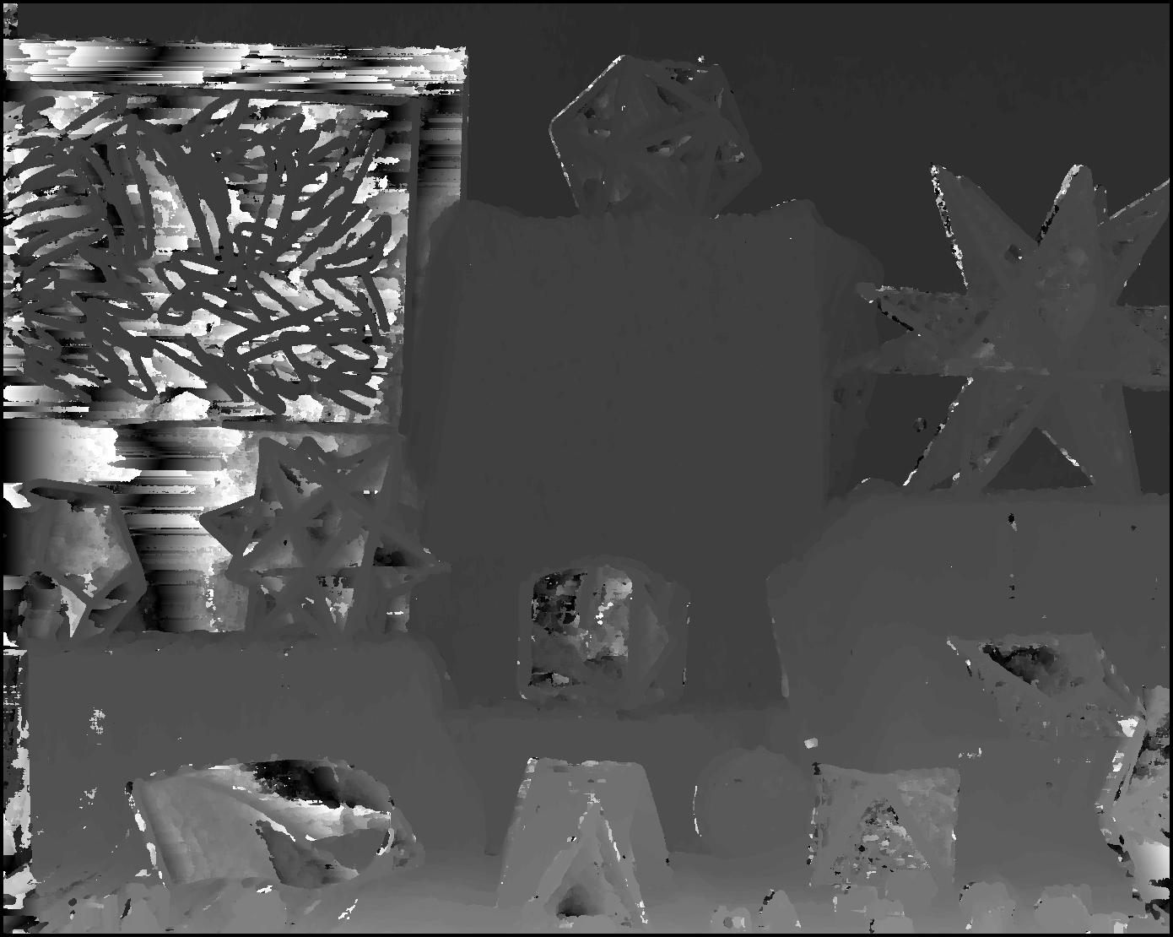

(c)

Figure 4. Results by using SAD with search range 200 and (a) window size: 3 (b) window size: 5 (c) window size: 9

From figure 4, we can clearly see that using window size 3 gives us a more precise view of the image that is the smaller window can extract those small features. However, the larger window size does have advantage which makes the image looks less noisy and more clearly to see. We can safely say that if we only want the overall view of the image, using large window size is a reasonable choice.

The searching range also affects the performance as well. We compare the performance with different search range of 200, 500, and 800, respectively. The experiment is done by using SAD with window size of 3 and 9, respectively. The results are shown in Figure 5 and Figure 6.

 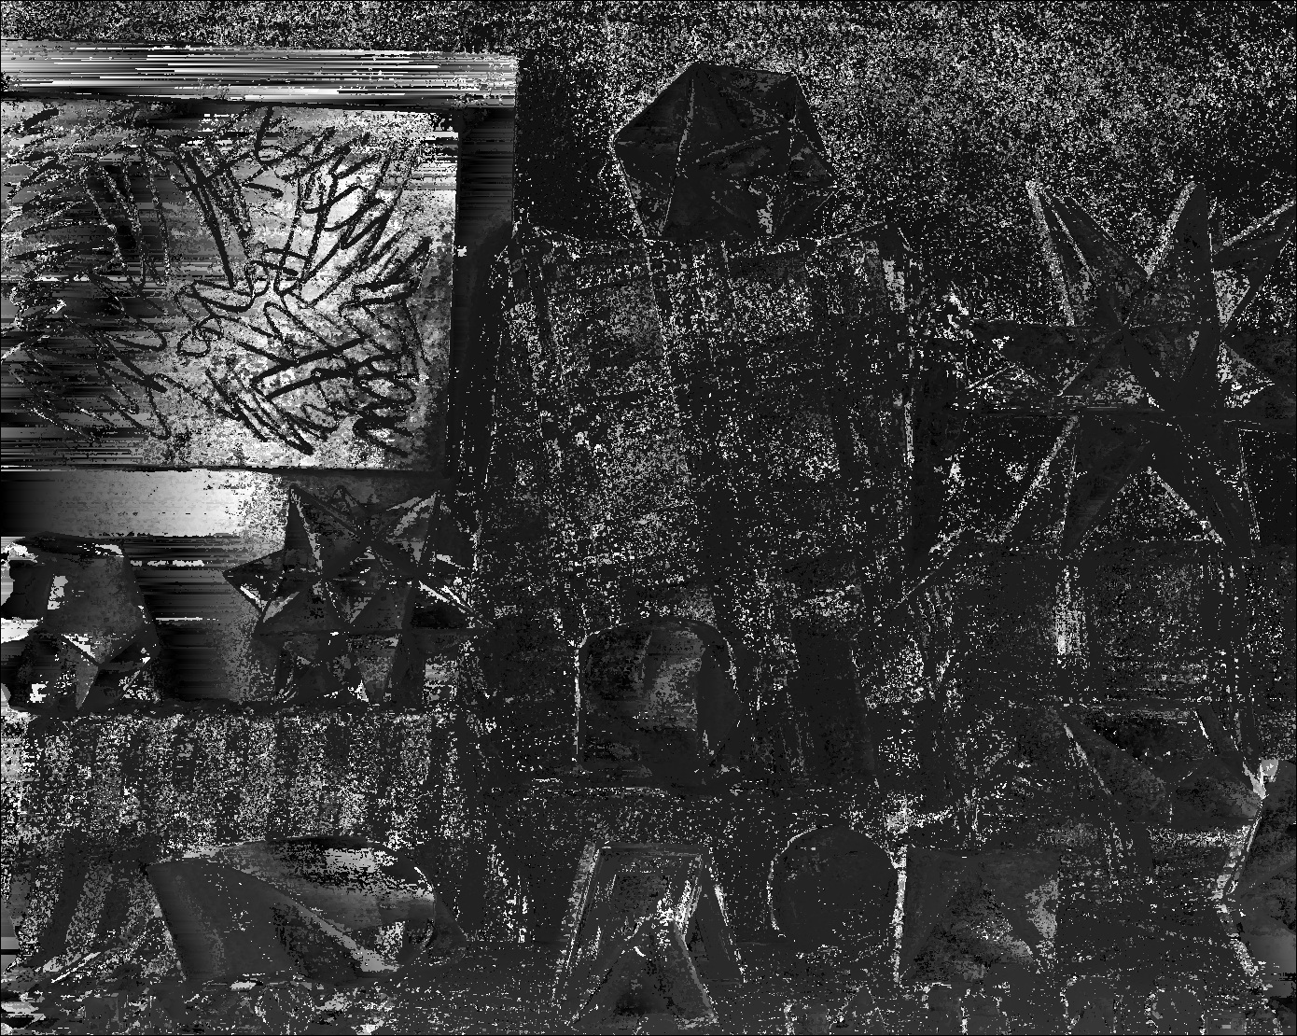

(a) (b)

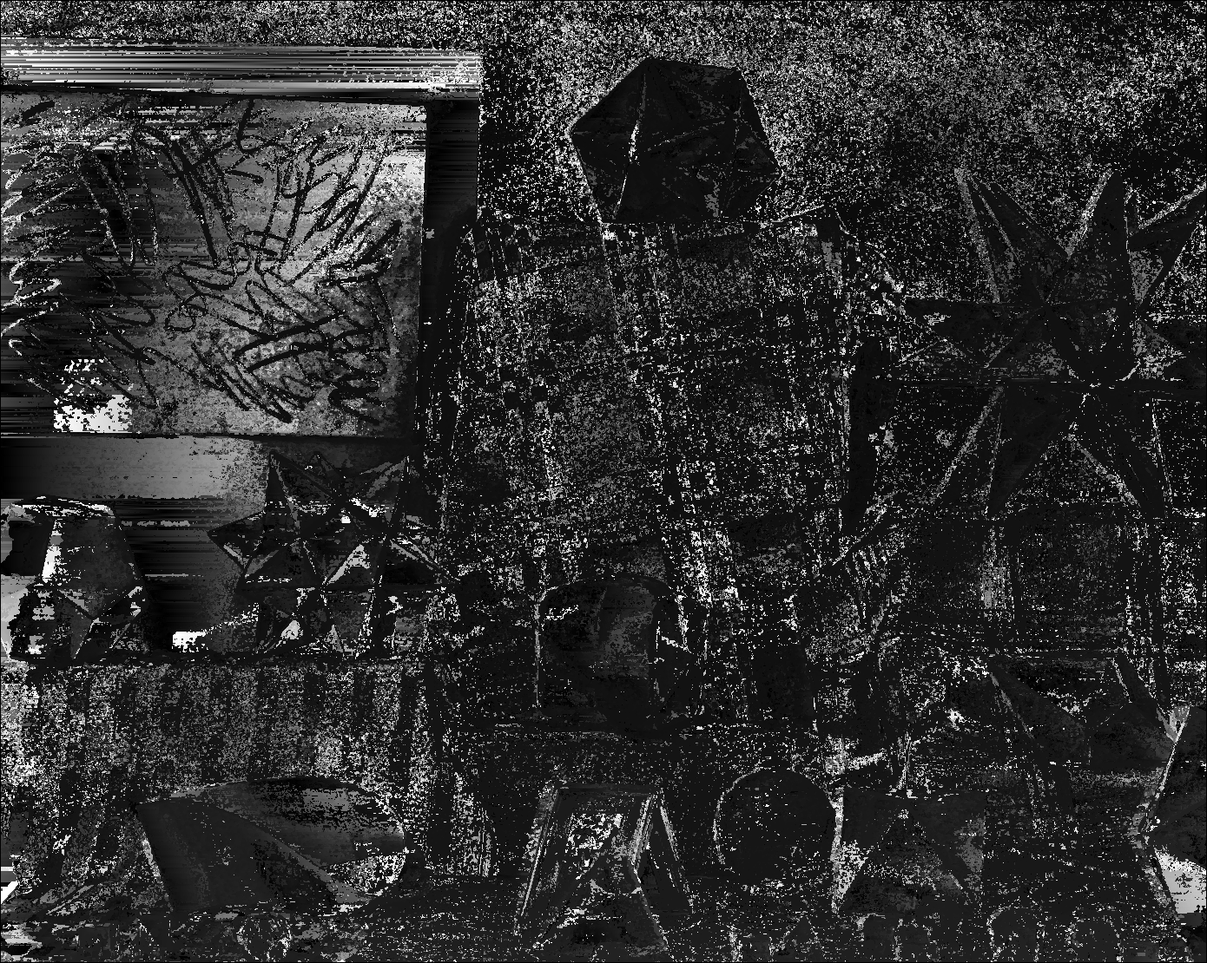

(c)

Figure 5. Results by using SAD with window size 3 and (a) search range: 200 (b) search range: 500 (c) search range: 800

 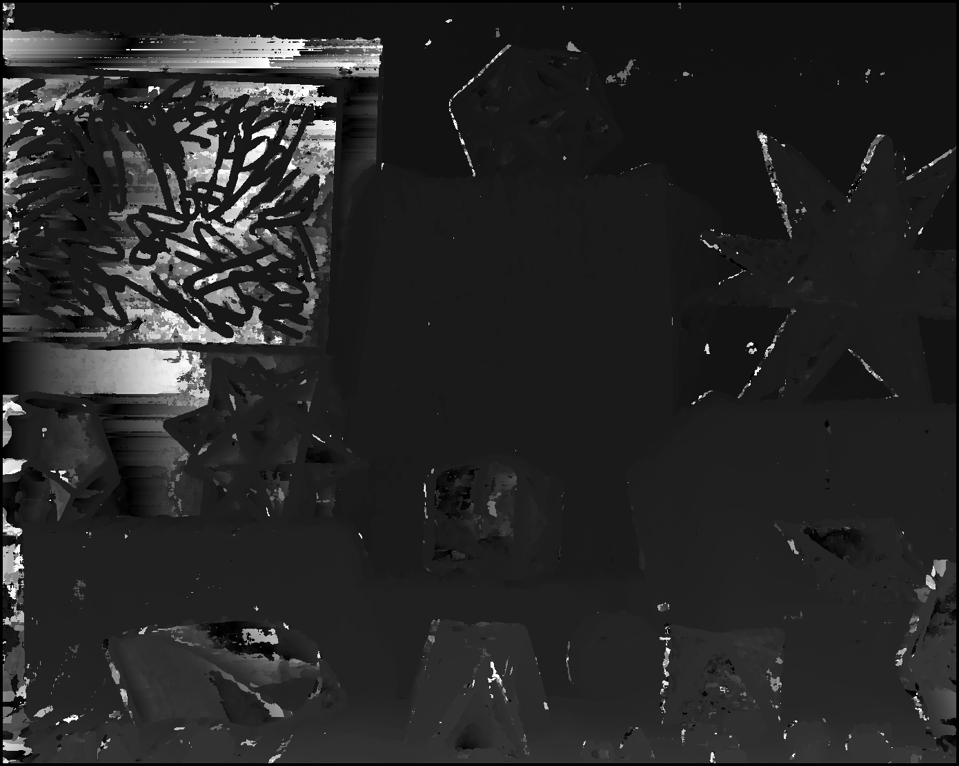

(a) (b)

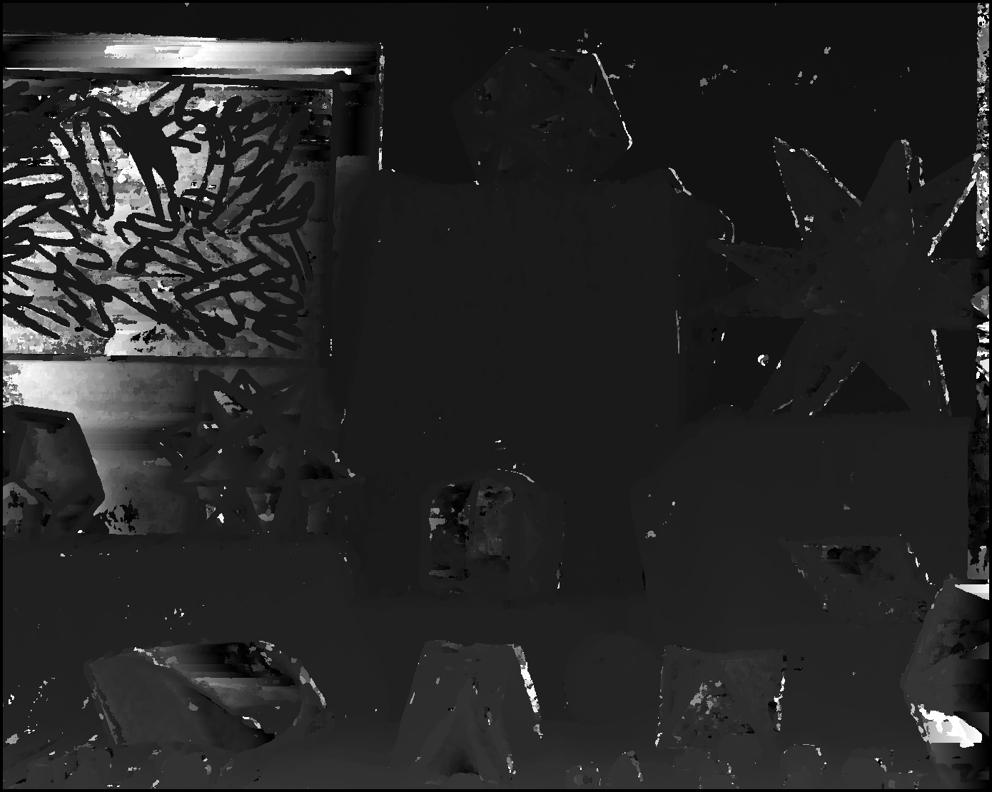

(c)

Figure 6. Results by using SAD with window size 9 and (a) search range: 200 (b) search range: 500 (c) search range: 800

From figure 5 and figure 6, we can see that the higher search range is set the darker the image is. Search range of 200 is probably high enough in this example.

# Summary

From the discussion above, we summary the results of implementation of stereo correspondence as follows:

1. Methods of matching stereo windows play an important rule for stereo correspondence problem.
2. Smaller window size gives a better details matching while larger window size contains less noise and looks smoother.
3. SSD is the most time consuming technique.
4. Larger searching range shows better performance but the time complexity grows simultaneously.

# Conclusion

In this paper, we implement different techniques of finding stereo correspondence from two images taken by different cameras. We compare the performance and execution time for different types of methods. We also implement different window sizes and search ranges. For further improvement, some results can be applied: dynamic programming (DP) method was proposed by T. Luong and O. Faugeras to find the best path of disparity map for scan-line stereo [4], and Energy function-based global optimization method was derived by B. Caprile and V. Torre to find more smooth results [5]. Energy functions of this form can be minimized using graph cuts and perform well on 2-D grid images. In the future works, we will improve our methods by using different techniques mentioned above not only for optimization purpose but also for performance enhancement.

References

1. Daniel Scharstein and Richard Szeliski, “High accuracy stereo depth maps using structured light” *IEEE Pattern Analysis and Machine Intelligence*, vol. 1, pp. 195-202, June. 2003.
2. D. Forsyth and J. Ponce, *Computer Vision: A Modern Approach*, Prentice Hall, 2003.
3. C. Loop and Z. Zhang “Computing Rectifying Homographies for Stereo Vision.” CVPR 1999.
4. T. Luong and O. Faugeras, “Advances in Computational Stereo” *IEEE Pattern Analysis and Machine Intelligence,* vol. 25, pp. 993-1008, Aug. 2003.
5. B. Caprile and V. Torre, “Fast Approximate Energy Minimization via Graph Cuts.” *IEEE Pattern Analysis and Machine Intelligence*, vol. 23 no 11, pp. 1222-1239, June. 2001.



**Yi-Chieh Liao** is now a graduate student in the Department of Computer Science and Engineering, **National Chung Hsing University**, Taiwan. His current research interests include Information Security, Cryptography, Artificial Intelligence (AI), Machine Learning and Deep Learning.

1. Y.-C. Liao is with CS S&P Lab., Department of Computer Science and Engineering, **National Chung Hsing University,**145 Xingda Rd., South Dist., Taichung City 402¸**Taiwan (e**-main: liao1230ho123@gmail.com).